UID – **19BEC1034**

**Exp. No: 11** **Design a system for washing machine such that whenever it is filled, a red LED turns ON and if it is empty a green LED blinks for once every 20ms.**

**THEORY**

**Circuit Diagram :**

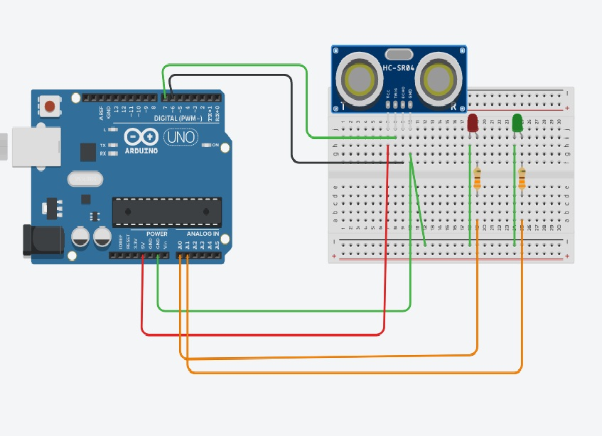

**Concepts : When** the ultrasonic sensor senses the distance of the water level it sends signals to the red and the green LED accordingly programmed.

**Learning And Observation**: I learnt to connect arduino with Ultrasonic Sensor and program it the work accordingly.

**CODE:**

**int triggerpin= 7;**

**int echopin = 6;**

**int red=A0;**

**int green=A1;**

**void setup()**

**{**

**Serial.begin(9600);**

**pinMode(triggerpin,OUTPUT);**

**pinMode(echopin,INPUT);**

**pinMode(red,OUTPUT);**

**pinMode(green,OUTPUT);**

**}**

**void loop()**

**{**

**int duration,distance;**

**digitalWrite(triggerpin,HIGH);**

**delayMicroseconds(1000);**

**digitalWrite(triggerpin,LOW);**

**duration= pulseIn(echopin,HIGH);**

**distance= (duration/2)/29.1;**

**Serial.println("cm");**

**Serial.println(distance);**

**if(distance<10)**

**{**

**digitalWrite(green,HIGH);**

**delay(20);**

**}else**

**if(distance>200)**

**{**

**digitalWrite(red,HIGH);**

**}**

**}**

1. Faced problem in connecting the Echopin and Triggerpin with arduino, troubleshooted it by changing the wires connected INPUTS.
2. Faced Problem in connecting LEDS with Arduino.
3. Faced Problem In connecting The LEDS in Common GROUND.

Precaution And Troubleshooting:

1. Connecting Wires in Common For GND for All LEDS.
2. Connecting 5V, GND with Analog Input for Ultrasonic Sensor.

Learning And Outcomes:

To work With Ultrasonic Sensor With Arduino.